**Question 1:**

**Twitter Sentimental Analysis:**

Sentimental Analysis on the given data(static). Based on the data given, the result will be displayed as positive or negative.

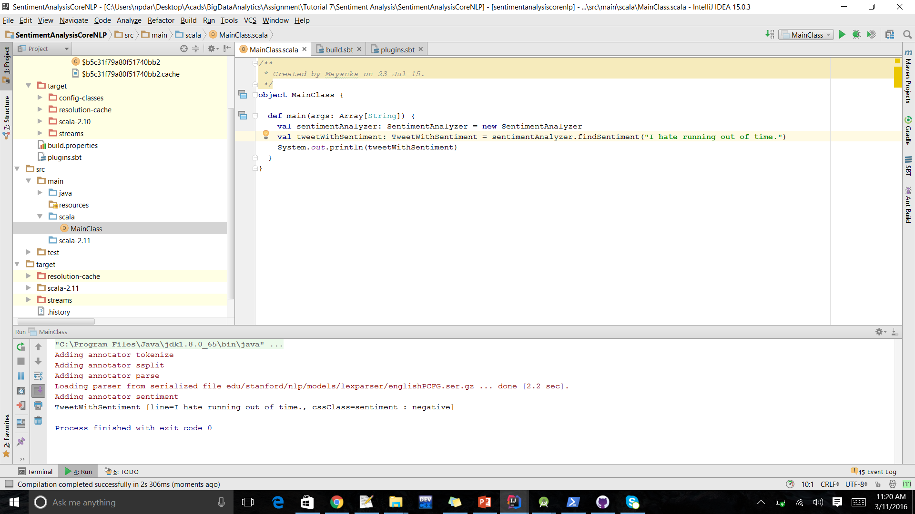

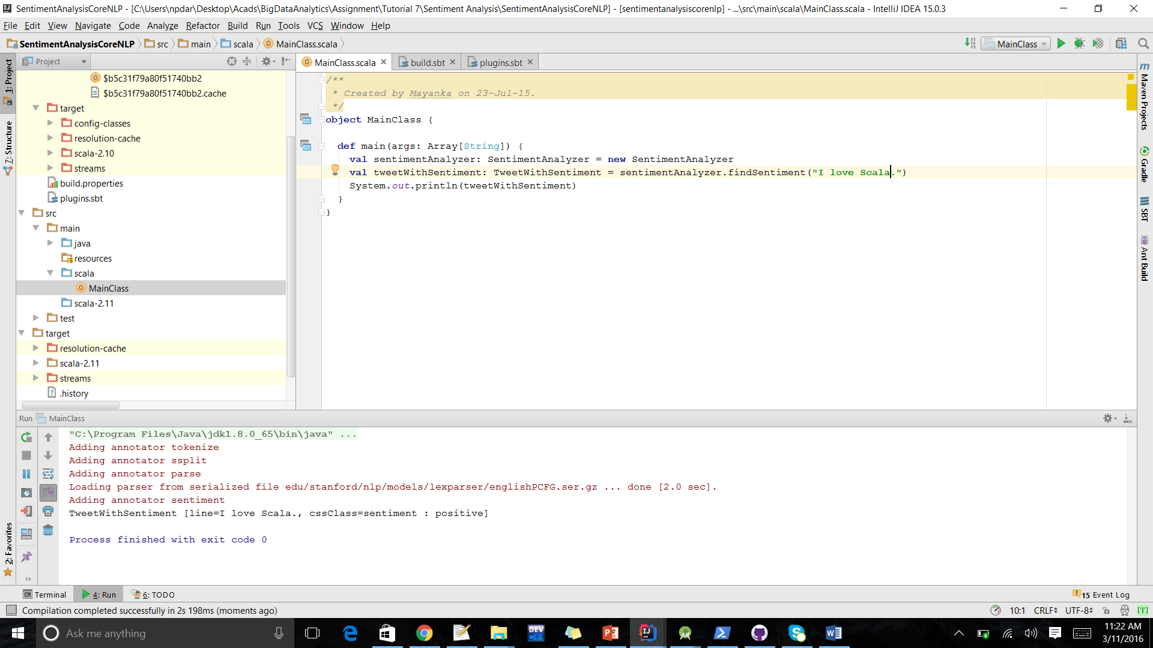

In this, I am able to provide the twitter live streaming data as an input. Here the sentimental analysis is taking place on streaming data and is able to analyze the data to be positive or negative.

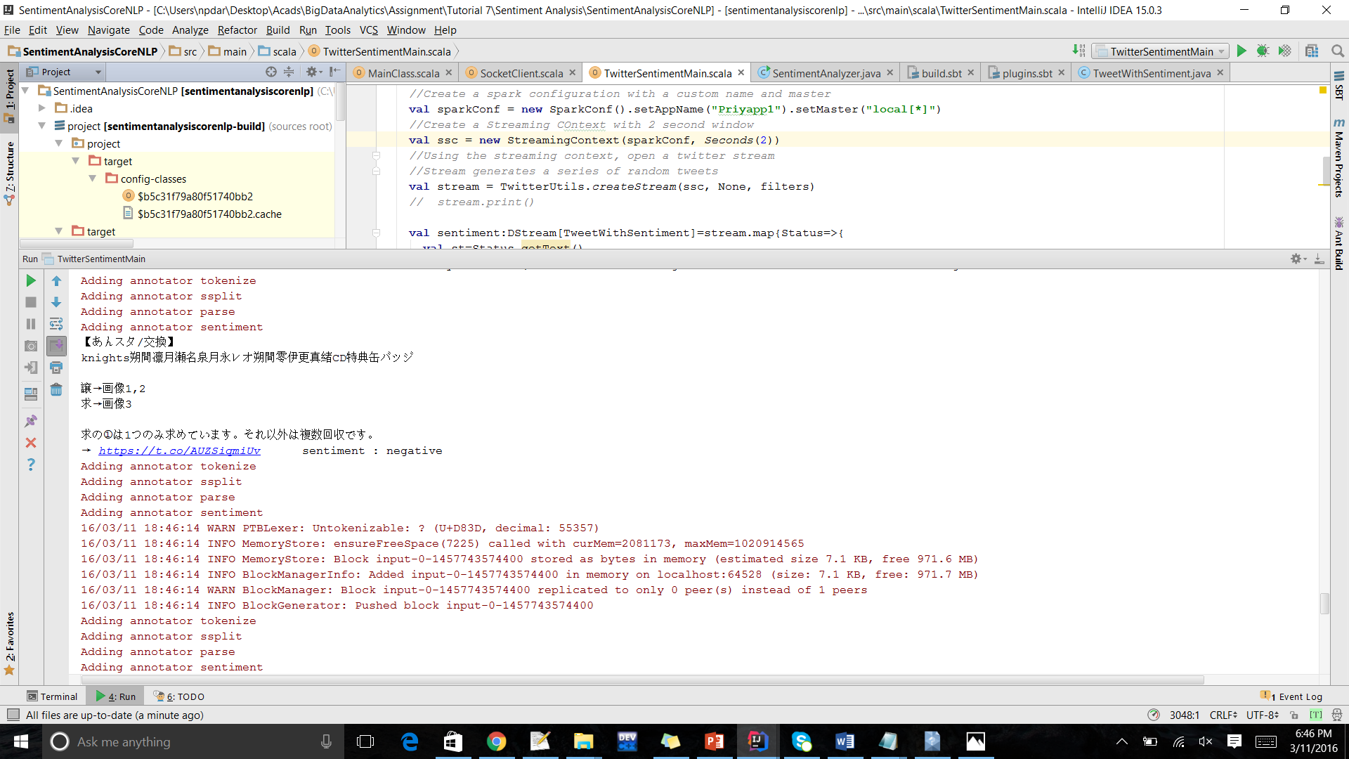

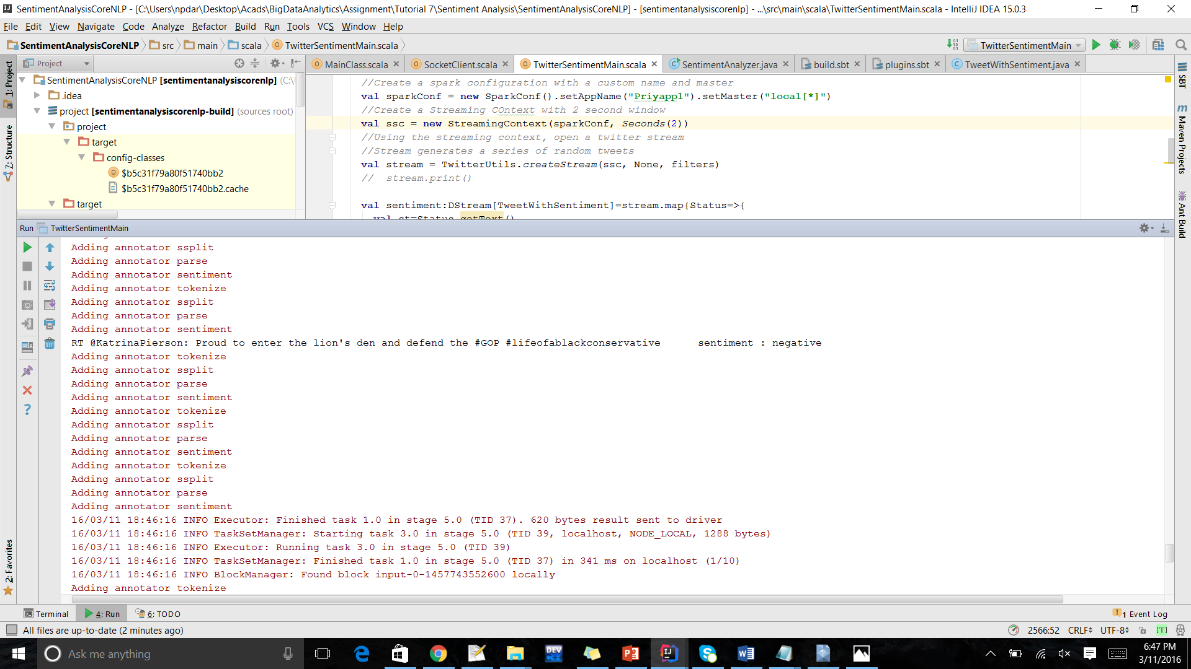

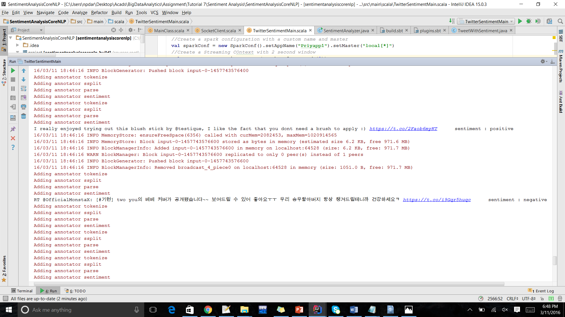

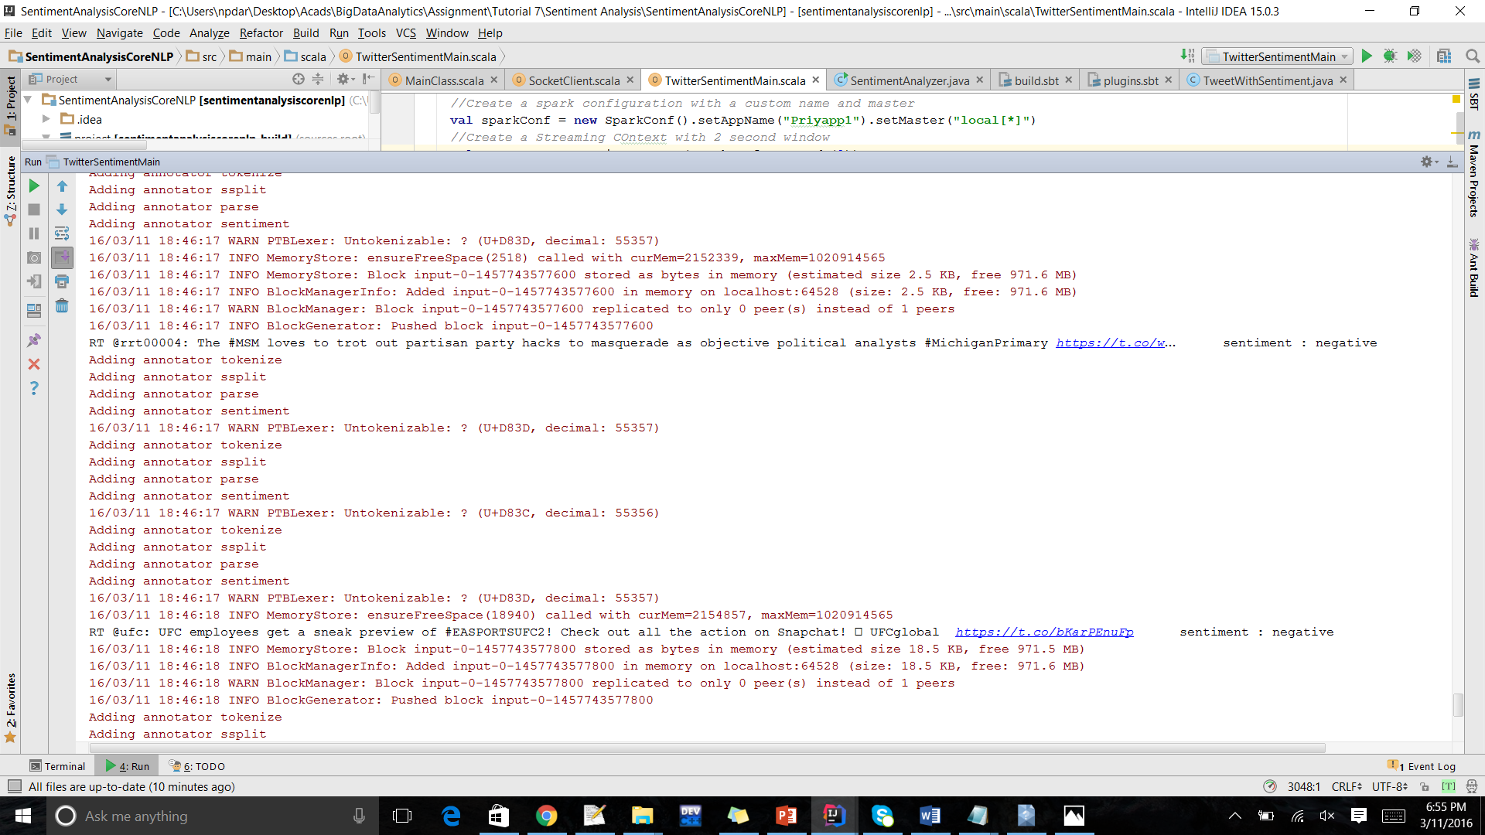

Question 2:

Recommendation System

In this I am able to provide the details of Books with the user id, ratings etc. My recommendation system will analyze the results based on the training data and will recommend the books.

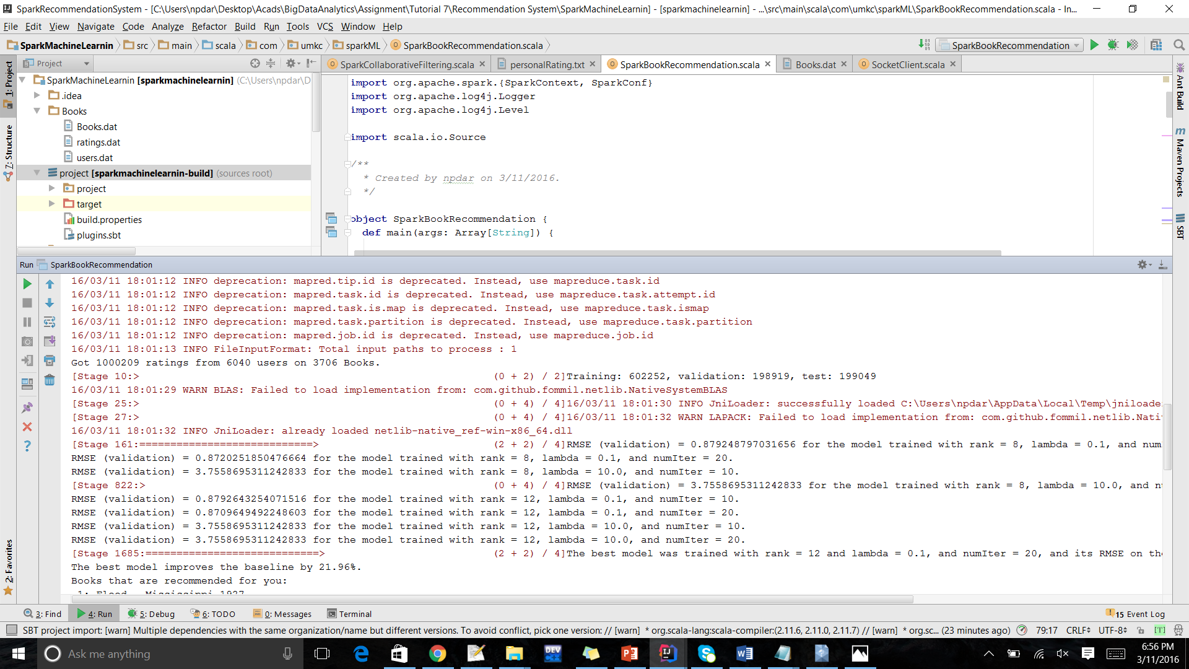

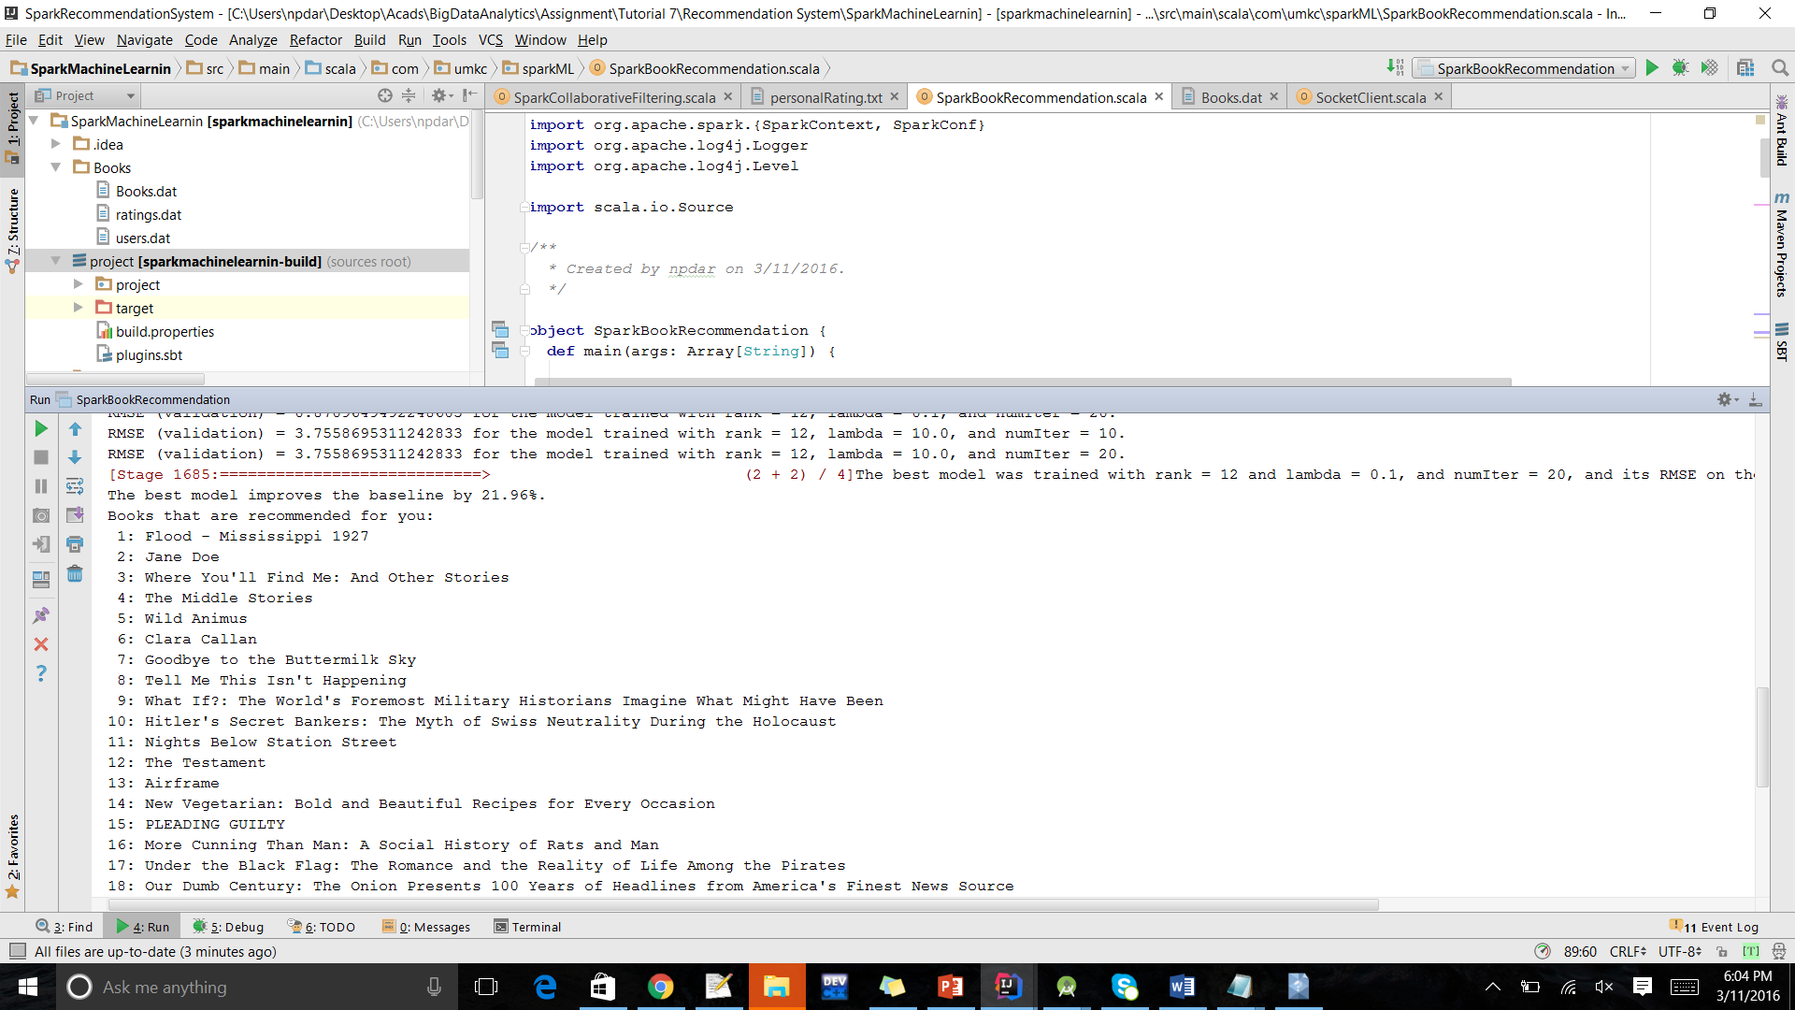

Question 3:

This question is related to the question-1. In this the data collected from the twitter will be analyzed using sentimental analysis and will be sent to any android device such as watch/ mobile in the form of notification.

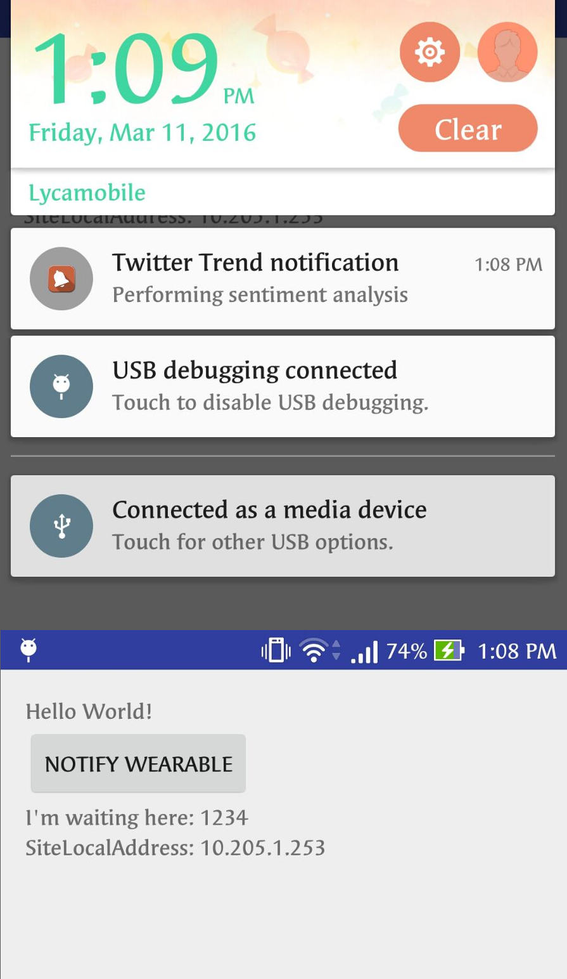

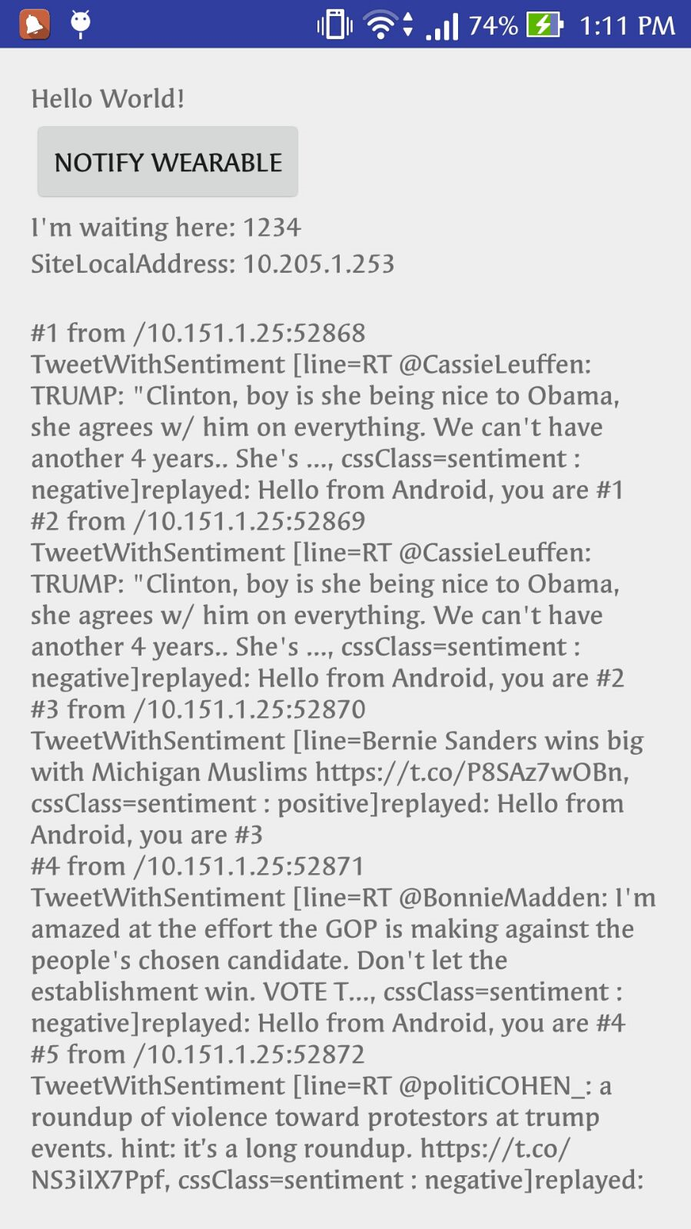

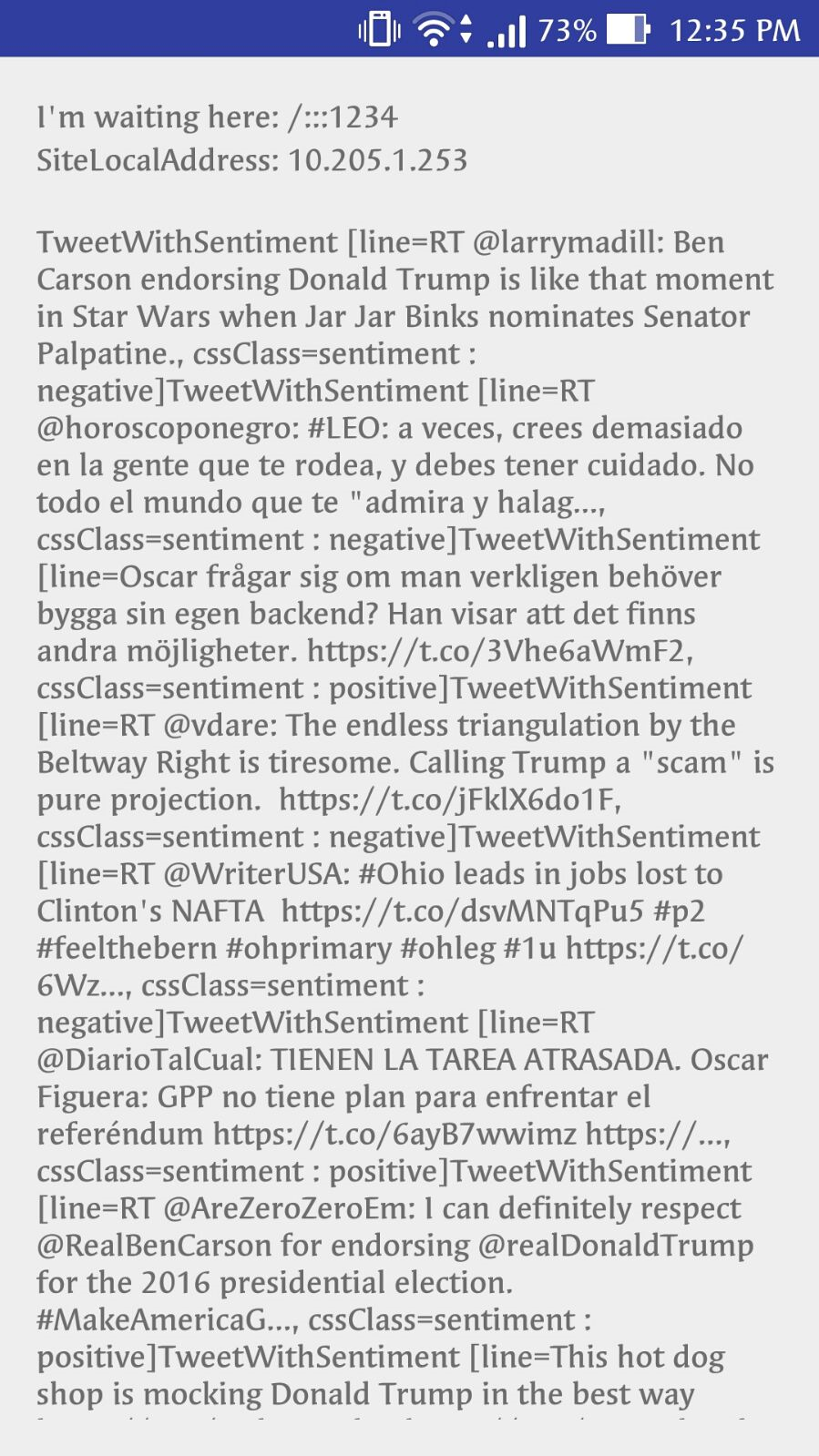

Question 4

A notification about the recommendation has been sent to the Android device.

